Physical Science

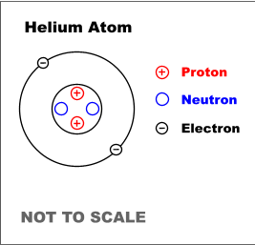
Student Name: Teacher:

Chemistry 2016-2017

Classroom Rules & Expectations

Classroom Rules

- Always ask permission to leave your seat.
- Please wait to be called on before answering or asking questions.
- Please come prepared to class which includes having items such as (pen, pencil, Paper, etc.)
- Please ask permission to touch any equipment in the classroom. (includes lab computers)
- Always be attentive and silent when the teacher or anyone is presenting in class.

Classroom Expectations

Be Respectful | - Talk at appropriate times using voice level 2-3  - Choose positive words to express your thoughts/opinions  - Wait your turn to speak  - Ask permission to use materials belonging to others  - Maintain personal space of others | Accountability:  - Up to 3 verbal/non-verbal warnings/prompts  - Call home + ASD referral  - Office Referral
Be Safe | - Follow laboratory rules  - Follow teacher directions  - Report concerns to the teacher  - Walk when needing to move in the classroom  - Store personal materials under desk and away from walking areas  - Keep hands/feet to yourself | Voice Levels:  0 = Silent/voice  1 = Whisper  2 = Partner Voice  3 = Presentation/Speaking to the class  4 = Playing Outside
Be Responsible | - Be on time to class  - Turn cell phones off and store in book bag  - Bring your charged laptop to class  - Bring notebook, agenda book, and pencil to class  - Put classroom materials back in their storage areas after use  - Eat food and drink beverages in the cafeteria
Be a Learner | - Listen to directions  - Raise your hand to ask questions if there is something you don’t understand  - Start task within 30 sec. when a task is assigned.  - Stay on-task using your personal best  - Use voice level 0 when completing independent work  - Complete homework when it is assigned  - Keep an organized notebook  - Use good study skills

Student Safety Contract

PURPOSE
Science is a hands-on laboratory class. However, science activities may have potential hazards. We will use some equipment and animals that may be dangerous if not handled properly. Safety in the science class- room is an important part of the scientific process. To ensure a safe classroom, a list of rules has been developed and is called the Science Safety Contract. These rules must be followed at all times. Additional safety instructions will be given for each activity.
No science student will be allowed to participate in science activities until this con- tract has been signed by both the student and a parent orguardian.
SAFETY RULES
- Conduct yourself in a responsible manner at all times in
the science room. Horseplay, practical jokes, and pranks will not betolerated.
- Follow all written and verbal instructions carefully. Ask
your teacher questions if you do not understand the instructions.
- Do not touch any equipment, supplies, animals, or
other materials in the science room without permission fromthe teacher.
- Perform only authorized and approved experiments.
Do not conduct any experiments when the teacher is out of the room.
- Never eat, drink, chew gum, or taste anything in the
scienceroom.
- Keep hands away from face, eyes, and mouth while
using science materials or when working with either chemicals or animals. Wash your hands with soap and water before leaving the science room.
- Wear safety glasses or goggles when instructed. Never
remove safety glasses or goggles during an experiment.
There will be no exceptions to this rule!
- Keep your work area and the science room neat and
clean. Bring only your laboratory instructions, worksheets, andwriting instruments to the workarea.
- Clean all work areas and equipment at the end of the
experiment. Return all equipment clean and in working order to the proper storagearea.
- Follow your teacher’s instructions to dispose of any
waste materials generated in an experiment.
- Report any accident (fire, spill, break- age, etc.), injury
(cut, burn, etc.), or hazardous condition (broken equipment, etc.) to the teacher immediately.
- Consider all chemicals used in the science room to be
dangerous. Do not touch or smell any chemicals unless specifically instructed to do so.
- Treat all preserved specimens and dissecting supplies
with care and respect.
  - Do not remove preserved specimens from the scienceroom.
  - Use scalpels, scissors, and other sharp instruments only as instructed.
  - Nevercutanymaterialtowardsyou— always cut away from your body.
  - Report any cut or scratch from sharp instruments to the teacherimmediately.
- Never open storage cabinets or enter the
prep/storage room without permission from the teacher.
- Do not remove chemicals, equipment, supplies, or
animals from the science room without permission from the teacher.
- Handle all glassware with care. Never pick up hot or
broken glassware with your bare hands.
- Use extreme caution when using matches, a burner, or hot plate. Only light burners when instructed and donot put anything into a flame unlessspecifically instructed to do so. Do not leave a lit burner unattended.
- Dress properly—long hair must be tied back, no
dangling jewelry, and no loose or baggy clothing. Wear aprons when instructed.
- Learn where the safety equipment is located and how
to use it. Know where the exits are located and what to do in case of an emergency or fire drill.

**These rules and procedures are based on the Flinn Scientific, Inc Safety Contract. They are designed to ensure the safety of all instructors and students during labs. **

Violation of the laboratory rules and procedures could result in a zero for the lab activity, removal from the lab, and/or possibly losing privileges to all lab activities.
AGREEMENT

I, ,
(student’s name) have read and under- stand each of the above safety rules set forth in this contract. I agree to follow them to ensure not only my own safety but also the safety of others in the science classroom or laboratory. I also agree to follow the general rules of appropriate behavior for a class- room at all times to avoid accidents and to provide a safe learning environment for everyone. I understand that if I do not follow all the rules and safety precautions, I will not be allowed to participate in science activities.

Student Signature

Resources

Resource | URL | Username | Password
Brainpop | https://www.brainpop.com/ | ccsdis | pop
PhET | https://phet.colorado.edu/
Explore Learning | explorelearning.com
FOSS Student Web | https://www.fossweb.com/studenthome
Kahoot | https://kahoot.it/#/
Online Calculator | http://www.online­calculator. com/
Online Stopwatch | http://www.online­stopwatch  .com/
Quizizz | http://quizizz.com/

Blank Page

*Please do not write on this page. We may use it for an activity*

States of Matter

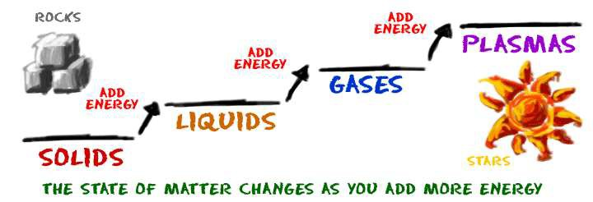

Experimental Design Practice

Directions: You are given the independent and dependent variables for an experiment. Create a hypothesis to match. Remember to put in the “If…..then” format.

- Independent Variable: The number of recycling posters.
Dependent Variable: The total number of cans being recycled.

- Independent Variable: Number of light bulbs on a front porch.
Dependent Variable: Number of bugs at night on the porch.

Directions: You are given a hypothesis – you need to identify the independent and dependent variables in each question.

- If the amount of sugar added to water is increased, then the amount of hummingbirds attracted to the water will increase.

Independent Variable: Dependent Variable:

- If the depth of Lake Erie increases, then the temperature will decrease. Independent Variable: Dependent Variable:

Directions: Using an experimental example to write a hypothesis and identify the variables

- Kayla wanted to see if caffeine helped improve how her friends did on their science test. After making sure that they all studied the same amount, she gave Monica, Brittany, and Chelsea three Cokes a half hour before their test. She took Brandy, Jadia, and Shae and let them take their science test with no caffeine at all. They all took the test at the same time and in the same room.

Experimental Design Foldable

Metric Conversion Practice
Directions: Use the metric conversion ladder to complete the following chart.

1 | 1m | = |  | cm | 10 | 1m | = |  | hm
2 | 1cm | = |  | mm | 11 | 1mm | = |  | m
3 | 25m | = |  | cm | 12 | 72m | = |  | dam
4 | 3km | = |  | cm | 13 | 2.7km | = |  | m
5 | 4,500mm | = |  | m | 14 | 700,000m | = |  | km
6 | 579km | = |  | cm | 15 | 21,893cm | = |  | m
7 | 19,847cm | = |  | dam | 16 | 869dm | = |  | km
8 | 596cm | = |  | mm | 17 | 789mm | = |  | m
9 | 895dm | = |  | dam | 18 | 324km | = |  | dm

Metric Conversion Ladder

Use the phrase ‘King Henry Doesn’t Usually Drink Chocolate Milk’ to help you remember the order of the units for the metric system.

K- Kilo- King

h-Hecto-Henry

da-Deka- Doesn’t

U-Basic Unit- Usually

d-Deci- Drink

c-Centi-Chocolate

m-Milli-Milk

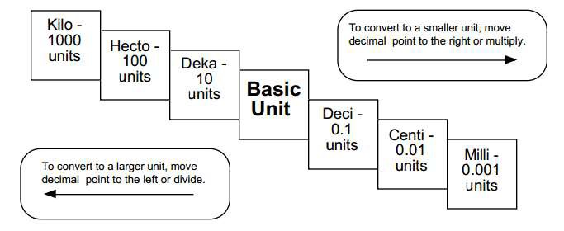

Science Equipment Everywhere!

Directions: Sort the pictures into the correct category.

Mass | Volume

What equipment at how home do you use to measure mass and volume?

Cornell Notes | Topic/Objective: |  | Name:
 | Mass, Volume and Density |  | Class/Period:
 |  |  | Date:
Essential Question: How do we measure mass and volume? What is density? How do we use density to identify substances?
Questions: |  | Mass is a measurement of matter is in an object. Mass is measured in , by a .  Weight is mass plus the applied to that mass.  Volume is the amount of a substance or object occupies.  - The volume of a liquid or gas can be measured with  using units .  - The volume of a regularly shaped solid can be calculated measuring the  , and and multiplying them together.  - Measure the amount of in a .  - Drop in the .  - Determine how much the water has risen.  Density is the of an object divided by its . density = _mass_  Volume  The density of ice is than that of water, so it floats.
What is mass and how is it measured?
How are mass and weight different?
What is volume?
How can volume be measured?
How is water displacement used to measure the volume of an object?
What is density?
How does solid water(ice) float on liquid water?
Summary:

Density Problem Practice

  - Calculate the density of a material that has a mass of 52.457g and a volume of 13.5cm3. (Don’t forget units)

  - A student finds a rock on the way to school. In the laboratory he determines that the volume of the rock is 22.7ml and the mass is 39.943g. What is the density of the rock? (Don’t forget units)

  - A student has a chunk of silver with a mass of 136.29g and using water displacement they were able to determine the volume is 12.993ml. What is the density of the chunk of silver? (Don’t forget units)

  - In the lab there is a block of pure Silicon that is 5cm wide, 7cm high, and 10cm long. The block has a mass of 817.6g, what is the element’s density? (Don’t forget units)

Density Foldable

Phase Changes Practice
What phase changes are occurring in the following descriptions?

- Tea pot boiling water and steam is making a whistling sound.

- Pouring hot silver into a mold and the silver forming into a heart shape solid.

- A nice cold soda in a glass starts to have water droplets on the outside of the glass.

- It was a cold Winter night and it started to rain but then the rain turned to snow.

- On a hot Summer day, the rain on the ground slowly turned to steam.

Phases & Phase Changes

The Particle Theory Practice

Cornell Notes | Topic/Objective: Particle Theory |  | Name:
 |  |  | Class/Period:
 |  |  | Date:
Essential Question: How can The Particle Theory explain how all matter (liquids, solids, gases) are structured and how they react under certain conditions?
Questions: |  | Notes:  - All matter is made up of very small .  - There is between particles.  - All particles in a are .  - The particles in matter are always .  - Particles are to each other.  - Particles are and have spaces between them.  - Particles move in .  - Have no definite or ; they  the container they are in.  - attraction between particles.  - Particles are .  - Particles move than .  - Have a definite but not shape; they the container they are in.  - Particles are bonded and over each other.  - Particles are .  - Particles move .  - Have a definite & .  - attraction between particles = bonds.  As energy is added to a substance, the increases and the  of the particle increases.
1. What are the 5 parts of The Particle Theory?
2. How do particles in a
GAS behave?
3. How do particles in a
LIQUID behave?
4. How do particles in a
SOLID behave?
5. What particles make up particles in a pure substance called?
6. How are energy, temperature and speed of particles related?
Summary:

Chemistry Vocabulary

Directions: Using the picture; come up with a sentence that explains the vocabulary word.

Vocab Word | Sentence | Picture
Scientific Method |  | 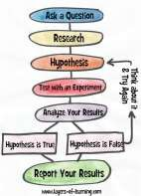
Independent Variable |  | 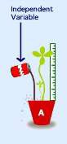
Dependent Variable |  | 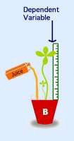
Matter |  | 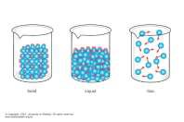

Mass |  | 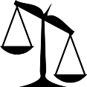
Volume |  | 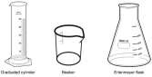
Length |  | 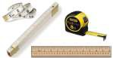
Liquid |  | 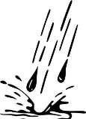
Control |  | 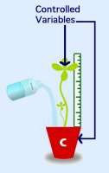
Density |  | 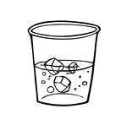

Water displacement |  | 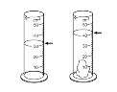
Meniscus |  | 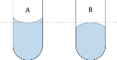
Constant |  | ?????
Hypothesis

Blank Page

*Please do not write on this page. We may use it for an activity*

Name: Date:

Properties of Matter Hidden Mystery Picture
To reveal the hidden picture below, color the physical properties of matter gray, the chemical properties of matter brown, and the pieces with dots green. Color the empty pieces blue.

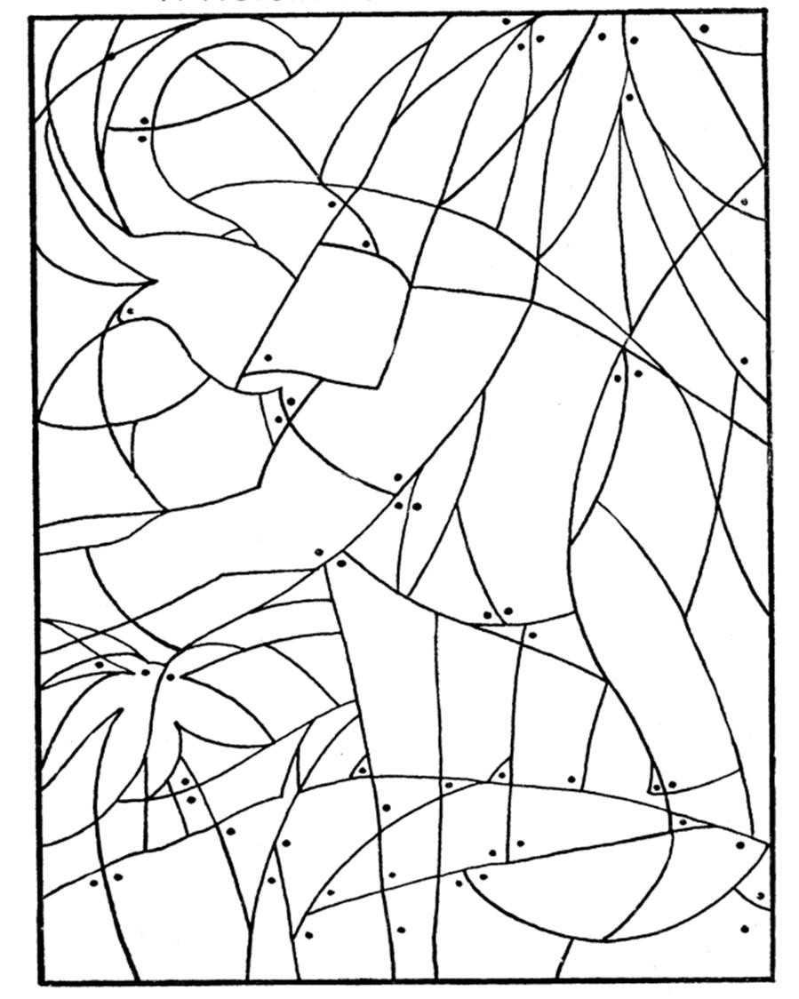color

luster

hardness

shape

metalloids

malleability
burns

mowing the grass

ductile

measureable

observable with your senses

metals

smoke

mass
changes can be reversed easily
odor

state of matter

freezing water
soluble

magnetic

density
volume

boiling

conductivity

reacts with air

production of a gas

bubbling

explosion

frying an egg

oxidation

combustible

non-metals

reacts with

rusted bicycle

color change

digestion
rotting

chemical change

fizzing

flammability
irreversible
light

reacts with water
rusts

Physical Properties

Blank Page

*Please do not write on this page. We may use it for an activity*

Chemical Properties

Physical and Chemical Changes Practice

Determine if the following descriptions are physical or chemical changes.

Change | P or C | Reason
1. Rusting Iron
2. Toasting Bread
3. Evaporating Water
4. Burning a candle
5. Frost on a car window
6. Boiling water
7. Formation of clouds
8. Baking a cake
9. Breaking a stick
10. Frying an egg

True or False. If false, correct the underline portion of the statement so that it is true.
  - A physical change is a change of matter from one form to another without a change in chemical properties.
  - A physical change is a change that occurs when a substance changes composition by forming one or more new substances.
  - Color change is evidence that a chemical change may have occurred.
  - Fizzing or Foaming is evidence that a chemical change may have occurred.

Properties of Matter Sort

Physical | Chemical

Acid & Bases Sort

Acid | Bases

What is the most Acidic or Basic thing you’ve accidently or on purpose eaten??

Acid & Bases

Draw the pH Scale

Draw examples of the following

Element:

Compound

Mixture:

Elements, Mixtures and Compounds

Draw the particle description of the following

Element:

Compound

Mixture:

Elements, Mixtures and Compounds Foldable

Draw the particle description of the following

Element:

Compound

Mixture:

Blank Page

*Please do not write on this page. We may use it for an activity*

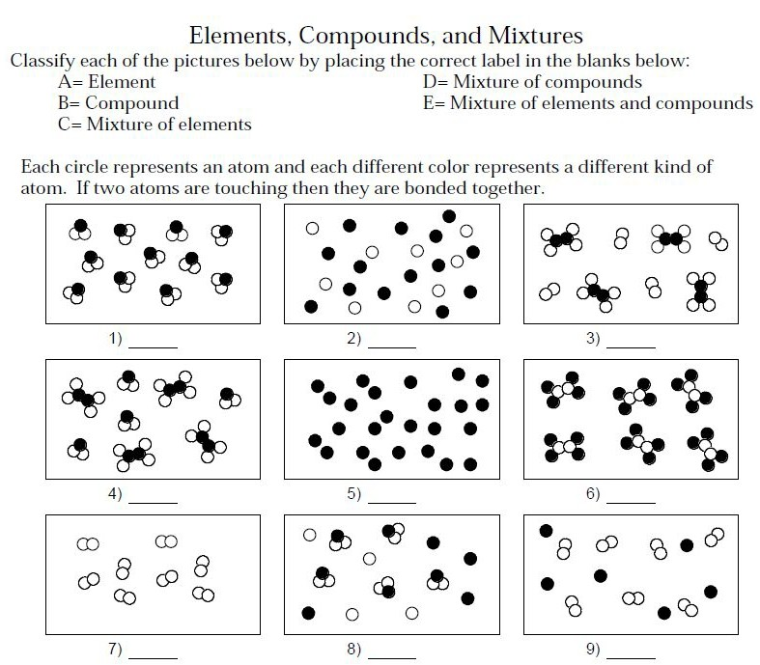
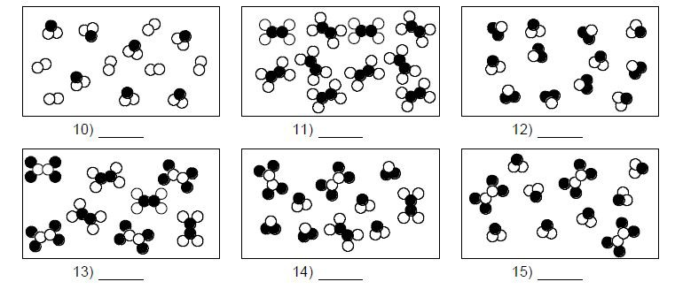

Use the following words to fill in the concept map:
nonmetal, mixture, metal, compound, pure substance, matter, element, metalloid, solution

If made of more than 1 element chemically combined
If cannot be separated into simpler substances physically or chemically

If appears to be
a single substance

Blank Page

*Please do not write on this page. We may use it for an activity*

The
Atom

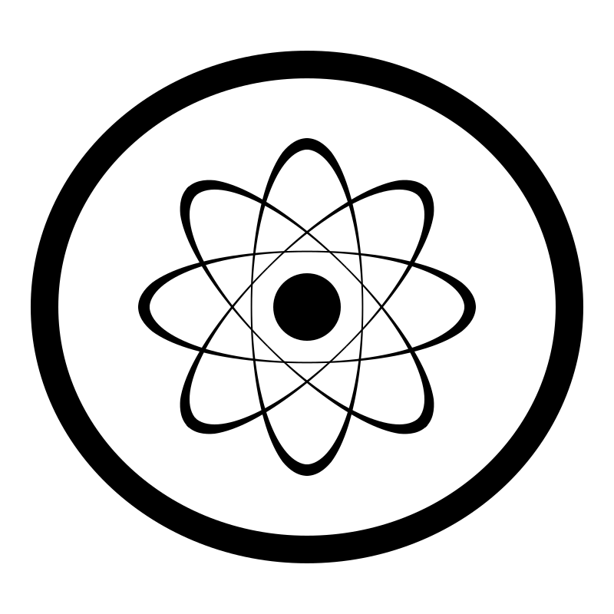

History of an Atom

Democritus | John Dalton
J.J. Thomson | Ernest Rutherford

History of an Atom

Niels Bohr
Modern Theory of an Atom: Electron Cloud Model

Draw your own Atom!
Directions: Now that we know the parts of the atom. Draw your own atom using as many protons, neutrons, and electrons as you want!

Atom Diagram

Directions: Identify the parts of the atom.

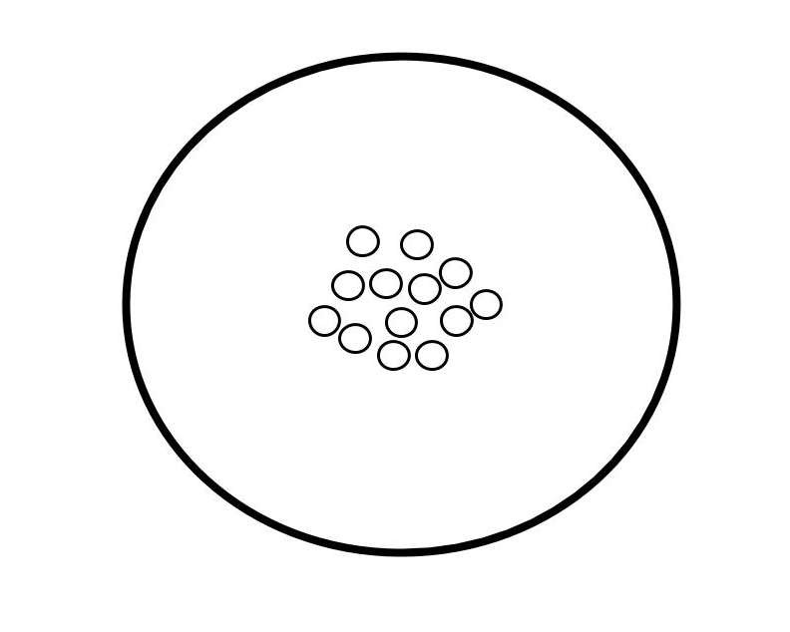

Atom Story

Directions: Create a story using the following vocabulary words electron, proton, neutron, nucleus, atomic number, atomic mass, atom, and atomic mass. **STORY MUST INCLUDE ALL VOCABULARY WORDS!**

Cornell Notes | Topic/Objective: |  | Name:
 | Periodic Table, Bohr Model, Valence |  | Class/Period:
 | Electrons, and Chemical Bonding |  | Date:
Essential Question: How can we use the periodic table and the Bohr Model of atomic structure to predict how atoms will chemically bond?
Questions: |  | created the periodic table of elements. We can use the periodic table to substances, and  how they , based on their .  The columns of the periodic table are called . The rows on the periodic table are called . Metals are elements found on the of the periodic table; nonmetals are found on the of the periodic table;  are found between metals and nonmetals.  and are found in the nucleus of an atom.  Electrons are filled in orbits also known as .  Electrons are filled in the energy level to the nucleus first then moving out.  The 1st energy level can hold electrons. The 2nd energy level can hold electrons. The 3rd energy level can hold electrons.  are electrons that are hanging out in the last energy level of the Bohr model  - Two non­metals valence electrons.  - Metals become charged by valence electrons to nonmetals, which become charged.
How can we use the periodic table?
How is the periodic table organized.
How does the Bohr model describe atomic structure?
What are the two ways that atoms can chemically combine together?
Summary:

Periodic Table Broken Down

Directions: Using the periodic table, fill in the blanks with the correct information

- The Vertical columns on the periodic table are called .

- The horizontal rows on the periodic table are called .

- Most of the elements in the periodic table are classified as .

- The elements that touch the zigzag line are classified as .

- The elements in the far upper right corner are classified as .

- Elements in the first group have one outer shell electron and are extremely reactive.

They are called .

- Elements in the second group have 2 outer shell electrons and are also very reactive.

They are called .

- Elements in groups 3 through 12 have many useful properties and are called

.

- Elements in group 17 are known as ‘salt formers’. They are called .

- Elements in group 18 are very unreactive. They are said to be inert. We call these

.

- The elements at the bottom of the table were pulled out to keep the table from becoming too long. The first period at the bottom called the .
The second period at the bottom of the table is called the .

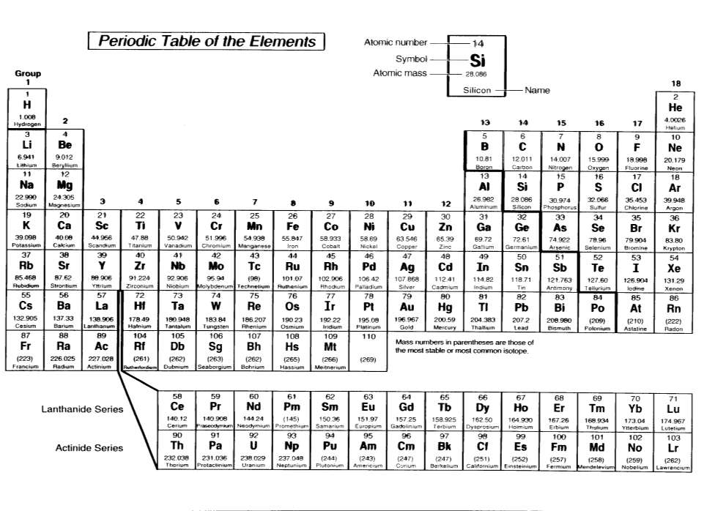

Use the periodic table to fill in the blanks correctly

Substance | Symbol | Atomic Number | Atomic Mass Rounded | Number of Protons | Number of Neutrons | Number of Electrons
Nitrogen
Sodium
Silicon
Aluminum
Iron
Magnesium
Chlorine
Niobium
Germanium
Phosphorus
Arsenic
Krypton
Xenon
Titanium
Cobalt

Periodic Table Notes

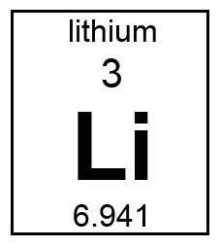

Substance | Symbol | Atomic Number | Atomic Mass Rounded | Number of Protons | Number of Neutrons | Number of Electrons
Lithium
Zinc
Cobalt

Bohr Model & Valence Electrons

Directions: Draw the Bohr model for the following elements and identify the number of Valence Electrons.

- Li

4. O

- Na

5. S

- P 6. Ar

Bohr Model Diagram

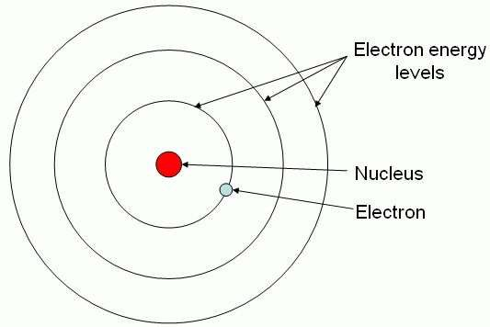

- The rings are the nucleus are the .

- The surround the nucleus.

- The stays in the middle of the atom.

- are always on the last level of the atom

Bonding Practice
Directions: Label the following chemical formulas with the correct bonds.

Types of Bonds
CH4
NaF
P2O3
LiBr
SO3
FeCl3

Determine if the following molecular diagrams are ionic or covalent.

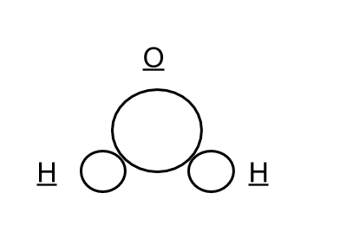
1.

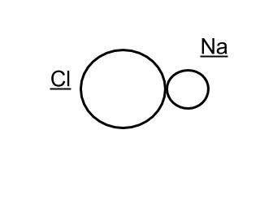
2.

Bonding

Directions: fill in the Venn diagram with the notes on bonding.

Ionic Bonding
Covalent Bonding

Directions: Mark a check next to the elements that will share or lose/gain electrons.

Element | Shared Electrons | Lose/Gain Electrons
Fe
Cl
Sn
V
P

Chemical Formulas Practice

Directions: Identify and determine the amount of elements and atoms for each of the following chemical compounds. Use the examples below to help you solve the remaining compounds.

Chemical formula | Elements | Atoms
HNO3 | Hydrogen, Nitrogen, Oxygen | 1 Hydrogen, 1 Nitrogen, 3 Oxygen
Pb(SO3)2
KMnO4
KCl
Na2SO4
Ca(NO3)2

  - KMnO4
    - K =
    - Mn =
    - O =
- Na2CO3
  - Na =
  - C =
  - O =

2. HCl

- H =
- Cl =

- NH4Cl
  - N
  - H =
  - Cl =

- AlPO4
  - Al =
  - P =
  - O =

- BaSO4
  - Ba =
  - S =
  - O =

ANALYZING SUBSTANCES
Name ----------------------
Period -------Date ------------

• • • • • • • • • • • • • • • • • • • • • • • • • • • • • • • • • • • • • • • • •

Substance name
Chemical
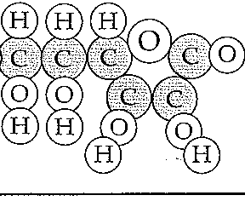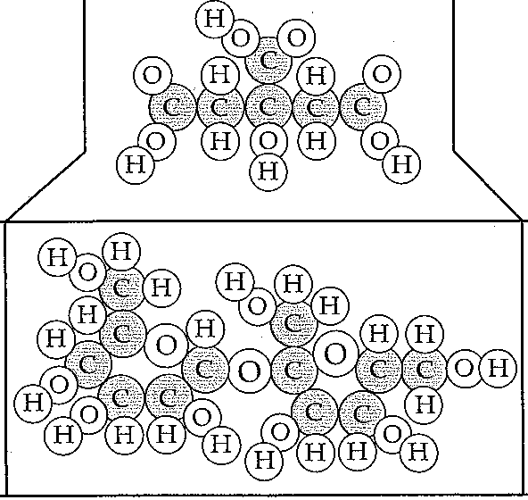formula Representation
Number of elements
Number of atoms

@@@

®

H

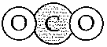

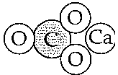

FOSS Chemical Interactions Course
© The Regents of the University of California
Can be duplicated for classroom or workshop use. 87
Investigation 9: Reaction
Notebook Sheet

Chemical Equations Practice
Direction: Identify which parts of the equation are reactants and products then list the type and quantity of each atom.

  - H2 + Cl2 → HCl

  - NO + O2 → NO2

2H+ O → H2O

Cornell Notes | Topic/Objective: Chemical Equations |  | Name:
 | Describe what the parts of a chemical equation represent and how equations demonstrate the Law of Conservation of Mass. |  | Class/Period:
 |  |  | Date:
Essential Question: How do chemical equations represent chemical reactions and demonstrate the Law of Conservation of Mass?
Questions: |  | Notes:  A chemical reaction is when two or more atoms or molecules  or to form a new .  A chemical equation is a symbolic representation of a  .  Chemical equations show , or what elements and compounds you start with on the side of the equation.  Chemical equations also show , or what elements and compounds you end up with after the chemical reaction has taken place, on the  side of the equation.  are numbers below and to the right of an element symbol that tell how many are found in the molecule.  H2 O2 Each molecule contains atoms.  are numbers found to the left of a chemical formal that tell how many are used/produced in the reaction.  3CO2 Contains CO2 molecules  Law of Conservation of Mass states that is neither created nor in ordinary chemical and physical changes.  Chemical equations showconservation of mass when the number of atoms of each element are the same on the and Sides of the equation
What is a chemical reaction?
What is a chemical equation?
What are reactants and products and where are they represented in a chemical equation?
How do we know how many atoms and molecules are reacting and being produced in a chemical reaction?
How do I know when an equation shows a conservation of mass?
Summary:

Balancing Chemical Equations

Balance the equations below:

1) N2 + H2  NH3

- KClO3  KCl + O2

- NaCl + F2  NaF + Cl2 4) H2 + O2  H2O
5) Pb(OH)2 + HCl  H2O + PbCl2 6) AlBr3 + K2SO4  KBr + Al2(SO4)3 7) CH4 + O2  CO2 + H2O
8) C3H8 + O2  CO2 + H2O

9) C8H18 + O2  CO2 + H2O

10) FeCl3 + NaOH  Fe(OH)3 + NaCl 11) P + O2  P2O5
12) Na + H2O  NaOH + H2

13) Ag2O  Ag + O2 14) S8 + O2  SO3
15) CO2 + H2O  C6H12O6 + O2

- K + MgBr  KBr + Mg

- HCl + CaCO3  CaCl2 + H2O + CO2

- HNO3 + NaHCO3  NaNO3 + H2O + CO2 19) H2O + O2  H2O2
- NaBr + CaF2  NaF + CaBr2

- H2SO4 + NaNO2  HNO2 + Na2SO4

WKS001x019 © 2000 Cavalcade Publishing (http://www.cavalcadepublishing.com) All Rights Reserved

Balancing Equations Foldable

Endothermic and Exothermic Reactions Practice

Decide whether each of these reactions is exothermic or endothermic:
- When two chemicals mix their temperature rises:

- A solid burns brightly and releases heat, light and sound:

- When two chemicals are mixed their temperature drops:

- Two chemicals will only react if you heat them continually:

- Plants take in light energy for photosynthesis:

- During chemical reactions the bonds between atoms break and new bonds form. Energy must be absorbed to break a bond, so breaking bonds is endothermic. Making new bonds is exothermic because energy is released.
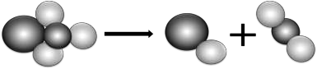
When green copper carbonate decomposes, the equation is:

CuCO3 | CuO | CO2
copper carbonate | copper oxide | carbon dioxide

Is the reaction exothermic or endothermic? Use ideas about bonds to explain why.

- A student wanted to compare the energy released when 4 different fuels burned. To make it a fair test she put 1 g of each fuel in a little dish. Then she burned each fuel under a calorimeter containing 200 cm³ of water. These are her results:

Fuel | Temp at the start in °C | Temp at the end in °C | Temp rise in °C
methanol | 25 | 56
ethanol | 18 | 53
propanol | 17 | 54
butanol | 23 | 63

- Calculate each temperature rise and state which fuel releases most energy per gram.

Cornell Notes | Topic: Energy and Rates of Chemical Reactions |  | Name:
 | Objective: Comparing endothermic and exothermic |  | Class/Period:
 | chemical reactions. |  | Date:
Essential Question: How do we classify chemical reactions in terms of energy and what factors affect the rates of these reactions?
Questions: |  | Notes:  Energy is when chemical bonds break in the reactant. Energy is when new chemical bonds form in the product  An Exothermic Reaction has occurred when:  - Energy is by the reaction.  - The energy of is greater than energy of .  - Examples: , , or are released.  An Endothermic Reaction has occurred when:  - Energy is by the reaction.  - The energy of is greater than energy of .  - Examples: , , or .  Energy is neither nor in chemical reactions.  Activation energy is the of energy needed for substances to react.  The rate of reaction is a measure of how the reaction takes place. An increase in temperature the reaction rate.  An increase in concentration the reaction rate.  An increase in the amount of exposed surface the reaction rate.  A catalyst the reaction rate by lowering the . An inhibitor the rate of reaction.
In terms of energy, what happens in a chemical reaction?
What is an exothermic
reaction?
What is an endothermic
reaction?
What is the Law of Conservation of Energy?
What is activation energy?
What is the rate of reaction and what can affect this?
Summary:

Name -- | -- | ------- | -- Class pate ------­
Chapter 8 |  |  | Using Science Skills: Classifying chemical reactions

Types of Reaction s

Chemical changes are characterized by the formation of nifw substances. The products of a correctly balanced chemical equation represent the number and kind of new substances formed. There are four general types ofreactions: synthesis, decomposition, single replacement, and double replacement.
Examine each equation listed below and identify which type of reaction is taking place by filling
in the blank space to the right of the equation.
- Then balance the equation. Remember to use coefficients, not subscripts, to balance the equation.
1. Al + 02 ----> AI.03

2, HgO ----> Hg + 02

3. NaOH + H,,804 ----> Na.SO, + H20

4. Fe + 02 ----> Fe,,Oa

5. Pb(N08). + K2Cr04 ----> PbCrO, + KN03

6, H2 + N2 ----> NHa

7, C3H5(N08)a ----> CO2 + N2 + H20 + 02 -----------

8. Fe + CuCI; ----> FeCl2 + Cu

9. KCIOa ----> KC! + 02

- Mg + HCI ----> H2 + MgCl2
© 1988 Prentice-Hall, Inc. Physical Science 331

Types of Reactions Foldable

Chemistry Glossary
acid: solution that tastes sour and has a pH of 0­7
atom: the smallest part of an element
atomic mass: the weighted average of the masses of all the naturally occurring isotopes of an element
atomic number: the number of protons in the nucleus of an atom balance/scale: a device used to measure the mass of an object base: solution tastes bitter, feels slippery, and has a pH of 7­14
Niels Bohr: 1913 proposed that electrons travel around the nucleus in specific paths found at different levels; planetary model
boiling: when a liquid vaporizes into a gas
compound: A pure substance composed of two or more elements chemically combined
condensation: The change of state(phase change) from a gas to a liquid constant: The portion of the experiment that always remains the same contract: To make smaller (decrease space between objects)
control: the variable of the experiment that the experimenter (scientist) uses to compare their findings to
covalent bond: the force of attraction between the nuclei of atoms and the electrons shared by the atoms
John Dalton: 1803 determined that atoms are the smallest particles of matter and cannot be divided and that atoms combine together to make new substances; bowling ball model
Democritus: ~400 BC proposed that all matter is made up of small particles called atoms
density: mass per unit volume of a substance
dependent variable: the variable in the experiment that changes due to the changes of the independent variable
electrons: the negatively charged particles found in all atoms; electrons are involved in the formation of chemical bonds.
electron cloud model: modern theory of atomic structure; electrons can be found in areas around the nucleus, but their specific path cannot be determined
element: a pure substance that cannot be separated or broken down into simpler substances by
physical or chemical means
evaporation: the change of state (phase change) from a liquid to a gas
expand: to make larger (increase space between objects)
freezing: the change of state(phase change) from a liquid to a solid
gas: the state where matter does not have a definite shape or definite volume
gram(g): basic metric unit of mass
group: a column of elements on the periodic table
independent variable: the variable in the experiment the ‘experimenter’ (scientist) changes
ionic bond: the force of attraction between oppositely charged ions
length: the distance of an object, measured from end to end
liquid: phase of matter with a definite volume, but no definite shape

Chemistry Glossary
liter(L): basic metric unit of volume
mass: amount of matter in an object
matter: anything that has mass and volume
melting: the change of state (phase change) from a solid to a liquid
meter(m): basic SI and metric unit of length
metric units: a system of units that are based on grams, liters, and meters
mixture: a combination of two or more substances that are not chemically combined
nucleus: the tiny, extremely dense, positively charged region in the center of an atom; made up of protons and neutrons
metals: elements that are shiny and good conductors of thermal energy and electric current; most metals are malleable and ductile
metalloids: elements that have properties of both metals and nonmetals; sometimes referred to as semiconductors
molecule: the smallest part of a compound; two or more elements
neutrons: the particles of the nucleus that have no charge
noble gases: the unreactive elements in Group 18 of the periodic table; their atoms have eight electrons in their outer level
nonmetals: elements that are dull and poor conductors of thermal energy and electric current
particle: a really small portion of matter
period: a horizontal row of elements in the periodic table
products: the substances formed from a chemical reaction
protons: the positively charged particles of the nucleus; the number of protons in a nucleus is the atomic number that determines the identity of an element
reactant: the starting materials in a chemical reaction
Ernest Rutherford: 1911 discovered the positively charged nucleus of atoms; negative electrons traveling around positive nucleus
scientific method: model or guide used to gather information and solve problems
solid: the state where matter has a definite shape and definite volume
JJ Thomson: 1897 identified electrons as particles found in every atom; plum pudding model
volume: amount of space something takes up
water displacement: a method of measuring the volume of an irregular shaped object by the amount of water it displaces
watershed: the area of land that includes a particular river or lake and all the rivers, streams, and tributaries that flow into it
weight: measure of the pull of gravity on an object
wetland: land that has a wet and spongy soil, such as a marsh, swamp, or bog
x­axis: the data that is plotted on the horizontal part of a graph
y­axis: the data that is plotted on the vertical part of a graph

Chemistry Review

1. Physical Property: | A. The change of state from a solid to a gas.
2. Density: | B. Vaporization that occurs throughout the liquid.
3. Matter: | C. Vaporization that occurs at the surface of a liquid below it’s boiling point.
4. Volume: | D. Change of state from a liquid to a solid.
5. Mass: | E. Change of state from a solid to a liquid.
6. Change of State: | F. State of matter that takes the shape of the container it is in.
7. Melting Point: | G. State of matter that does not have a definite shape or volume.
8. Boiling Point: | H. mass per volume
9. Vaporization: | I. the ability to dissolve in another substance.
10. Boiling: | J. The temperature at which a substance changes from a solid to a liquid.
11. Melting: | K. The state of matter that has a definite shape and volume.
12. Evaporation: | L. Property of matter that can be observed or measured without changing the identity of matter.
13. Solubility: | K. Property of matter that occurs when one or more substances are changed into entirely new substance.
14. Condensation: | L. The part of the experiment that you change.

15. Sublimation: | M. The part of the experiment that is the results or outcome.
16. Independent Variable: | N. The amount of matter that something is made.
17. Dependent Variable: | O. The amount of space that something occupies.
18. Liquid: | P. Anything that has volume and mass.
19. Solid: | Q. The change of state from a gas to a liquid.
20. Gas: | R. Change of state from a liquid to gas
21. Chemical Property: | S. The temperature at which a substance goes from a liquid to a gas.
22. Freezing: | T. The conversion of a substance from one physical form to another.

True/False

Indicate whether the statement is true or false.

1. Matter is anything that has mass and takes up space.

2. A physical property can be measured without changing the identity of the substance.

Multiple Choice

Identify the choice that best completes the statement or answers the question.

1.The density of aluminum is 2.7 g/cm3. What is the volume of a piece of aluminum if its mass is 8.1 grams?

- 3.0 cm3

d) 2.7 cm3 f) 0.33 cm3
2. A rock is dropped into a graduated cylinder filled with 35 mL of water.
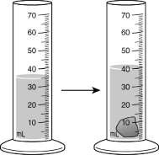
What is the volume of the rock? (Hint: 1 mL water = 1 cm3 )

b) 40 cm3

d) 14 cm3

f) 5 cm3

h) 35 cm3

3. Magnetism, solubility, and malleability are physical properties of matter. What makes these properties different from chemical properties?

b) Physical properties relate to elements rather than compounds.

d) Physical properties appear only after a chemical change occurs.

f) Physical properties can be observed without attempting to change the identity of the substance.
h) Physical properties describe elements in the solid state rather than in the liquid or gas state.

4. Which of these choices is a physical property that does not change when the size of the sample changes?
b) mass

d) volume

f) density

h) flammability

5. The pictures below show four objects—a paper clip, a pair of scissors, a needle, and a horseshoe.
Assume that each object is made of the same metal.

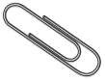
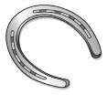
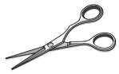
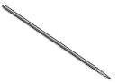

6. Which of these is a chemical property of a sheet of paper?

c) The paper can be burned.

e) The paper can be crumpled.

g) The paper does not attract a magnet.

i) The paper does not conduct electricity.

7. Which of these statements describes a chemical property of an object?

b) The object is white in color.

d) The object has a powdery texture.

f) The object’s density is 2.11 g/cm3.

h) The object reacts with acid to form water.

8. Some properties are the same in a substance no matter the amount of the substance. Which of the following properties does not change based on the amount of the substance?
b) density

d) mass

f) volume

h) Weight

9. All matter has physical and chemical properties. These properties can be used to identify the type of matter. Which of these statements describes a chemical property?
b) A particular substance evaporates at 30 °C.

d) A 2-ft.-long metal bar has a mass of only 176 g.

f) A certain heavy metal turns to a liquid at room temperature.

h) A metal is added to a beaker of water, and the beaker explodes.

10. The two beakers shown below contain pure water.
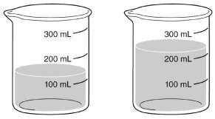

Which of these properties is the same for the water in both beakers?

b) mass

d) weight

f) density

i) volume

11. Which of these choices is an example of a physical property?

b) the tarnishing of silverware

d) the texture of a piece of chocolate

f) the effect of acid rain on automobiles

h) the combustion of gasoline in a car engine

12. Which of these statements best describes physical properties?

b) Physical properties behave identically for all matter under the same conditions.

d) Physical properties can be observed without changing the identity of a substance.
f) Physical properties are observed by seeing how a substance reacts with other substances.
h) Physical properties cause atoms and molecules to change structure when substances are mixed.

13. Which of these statements describes an example of a chemical property?

b) A silver statue begins to tarnish.

d) A painter coats a building with red paint.

f) A freshly waxed floor has a bright shine.

h) A metal turns to liquid at a certain temperature.

14. One chemical property that can be measured in a substance is its reactivity with water. What is another chemical property?

b) density

d) flammability

f) malleability

h) solubility

15. A beaker containing ice and water is placed on a warm hotplate. Will the ice in the beaker undergo a physical or chemical change?
- a physical change because it will change state

- a chemical change because it will change state

- a physical change because it will form a new substance

- a chemical change because it will form a new substance

Short Answer

  - An unknown substance has a volume of 2 cm3 and a mass of 38.6 grams. What is the density of the sample?

Material | Density (g/cm3)
Water | 1.0
Aluminum | 2.7
Iron | 7.9
Silver | 10.5
Gold | 19.3

Use the chart above to determine the identity of the unknown sample:

List three other physical properties that could be used to identify this sample.

  - Name a physical OR chemical property. Explain why this property is either physical or chemical.

Fill in the blank using the following words: (hint: some of your words might be used more than once)
Element, Compound, Metal, Nonmetal, Particle, Metalloid,

- A pure substance must be either a(n) or a(n) .
- Elements that are brittle and dull are .
- A (n) is pure substance composed of two or more elements chemically combined.
- A pure substance is a substance in which there is only one type of .
- A (n) is a pure substance that cannot be separated into simpler substances.
- are shiny, good conductors of thermal energy and electrical current.
- are semi-conductors that have properties of both metals and nonmetals.
Multiple Choice:
- Elements are divided into three categories:
  - Compounds, mixtures, and nonmetals
  - Mixtures, metals and compounds
  - Nonmetals, Metalloids, and Metals
  - Mixtures, Chemicals, and Compounds

- Which of the following best describes chicken noodle soup?
  - Element
  - Mixture
  - Compound
  - Solution

- Which of the following substances can be separated into simpler substance only by
chemical means?
  - Sodium
  - Salt water
  - Water
  - Gold

- What is the name of the element for Na as a symbol on the Periodic Table?
  - Magnesium
  - Radium
  - Niobium
  - Sodium

- What is the symbol for Potassium on the Periodic Table?
  - Rb
  - P
  - K
  - Pb

- What is the symbol for Vanadium on the Periodic Table?
  - Va
  - V
  - Vm
  - Vd

- Ag is the symbol for which of the following metals?

  - Argentium
  - Gold
  - Silver
  - Antimony

- Is Germanium a:
  - Metal
  - Nonmetal
  - Metalloid
  - Compound

- Is Phosphorus a:
  - Metal
  - Nonmetal
  - Metalloid
  - Compound

- Choose the combination of elements needed to create an Ionic bond.

- Choose the combination of elements needed to create a covalent bond.

Draw a Bohr model of a Boron (B) atom.

5

B
Boron
Scientists: Match the scientist/model with the description below. Each term will be used once.

  - Electron Cloud Model d. JJ Thomson

  - John Dalton e. Niels Bohr

  - Ernest Rutherford

- First to say that different elements had different types of atoms
- This is the model that we use today. It shows areas where you might find an electron.
- He discovered the atom is mostly empty space.
- He had the “plum pudding model” with electrons suspended in positively charged material.
- His model, also called the “planetary model,” it shows the electrons “orbiting” the nucleus in an orderly fashion.

Fill in the blanks with the following terms. Each word will be used once.

Period metals groups valence electrons periodic table energy levels atomic number nonmetals metalloids alkali metals

- The periodic table is organized into vertical columns called .

- These columns share the same number of .

- It is also organized into horizontal rows called .

- These horizontal rows share the same number of .

- Atoms increase in as you go across a row or down a column.
- There are a large number of on the periodic table. They are found on the left side of the stair-step.
- The are found on the right side of the stair-step.

- The elements touching the stairstep have some things in common with metals and some things in common with nonmetals. They are called or semimetals.
#15- 20 Fill in the chart. You may use a periodic table to answer these.

Element Name | Element Symbol | # of Protons | # Neutrons | #Electrons
Calcium | Ca |  | 20
 | Na |  | 12 | 11
 | Ag | 47 |  | 47

Fill in the blanks with the following terms. Some words may not be used!

atomic number, negative, positive, neutral, proton, electron, neutron, nucleus, charge, group, period, noble, gas, atomic mass, alkali metals, periodic table

- The center of an atom is called the .

- A proton has a charge.

- A neutron has a charge.

- If I add a proton to an atom, I change its .

- If I change the number of electrons on an atom, I change its and make an ion.

What You Need to Know (WYNTK):

  - What is the difference between the independent variable and dependent variable?

  - What is the importance of constants in an experiment?

  - What is the function of the control?

  - What are the SI units for length, mass, volume, and temperature?

  - Convert 500 cm to kilo, deci, centi, milli meters

  - What does the Particle Theory of Matter tell us about matter?

  - Describe the properties of the three states of matter in terms of shape and volume (definite or indefinite)

  - Describe the movement of particles in solids, liquids and gases.

  - What is the formula for finding the volume of a rectangular shaped solid?

    - What is the metric unit for volume of a solid?

- Describe how you would find the volume of an irregular shaped solid?

What is the metric unit for the volume of a liquid?

How do the metric units for the volumes of solid and liquid compare?

- What is density?

- How do you calculate density?

What is the metric unit for density? (p.27)

- What is the difference between a physical and chemical property of matter?

- Label a PP beside the following if it refers to a physical property and CP if it refers to a chemical property.

Rusting Density

Expansion and contraction Malleable

Combustible Oxidation

- Draw a pH scale from 0-14. On the scale label weak acid, weak base, strong acid, strong base and a neutral substance.

- What is the smallest particle of an element?

- What is the smallest particle of compound?

Chemistry Review

Directions: Using the periodic table fill in the blanks with the correct information for each element.

Element | Atomic Number | Atomic Mass | Protons | Neutrons | Electrons
N
Br
Kr
V
Ag
Ge
Cu
Zn
Ca
K

What's the Difference? Atom, Element, Molecule, Compound

Type of Matter | Definition | Sample Drawing | Symbol or Formula
ELEMENT | A pure substance made up of only one kind of atom that cannot be broken down into simpler substances.
ATOM | The smallest particle of an element that still keeps the properties of that element
MOLECULE | The smallest particle of a substance that has all the properties of that substance; made of of 2 or more atoms that are chemically bonded
COMPOUND | A substance made up of 2 or more different elements whose atoms are chemically bonded.

Atom? Element? Molecule? Compound?
Directions: Study each picture below. In the spaces provided, identify how many atoms, elements, molecules, and compounds there are.

1 2 3

atoms
elements
molecules compounds
atoms
elements
molecules compounds
atoms
elements
molecules compounds

4 5 6

atoms
elements
molecules compounds
atoms
elements
molecules compounds
atoms
elements
molecules compounds

7 8 9

atoms atoms atoms elements elements elements molecules molecules molecules compounds compounds compounds

Bohr Model and Valence Electrons Practice Directions: Use the periodic table to fill in the following table.
Element | Bohr Model | Valence Electrons
Carbon
Chlorine
Hydrogen
Phosphorus
Oxygen

Sulfur
Nitrogen
Sodium
Chlorine
Beryllium
Fluorine

Lithium
Oxygen
Phosphorus

Chemical Bonds
Directions: Please determine why type of chemical compound is for each of the following compounds. Don’t forget to use the periodic table to assist you.

CaCl2 |  | MgO
CO2 |  | HCl
H2O |  | KI
K2O |  | NO2
NaF |  | FeCl3
CH4 |  | P2O5
SO3 |  | N2O3
LiBr |  | NaCl

Valence Electrons
Directions: Using the periodic table, determine how many valence electrons each of the following elements have?

Element | Valence Electrons
Fluorine
Lithium
Phosphorus
Calcium
Nitrogen
Iron
Argon
Potassium
Helium
Magnesium
Carbon
Oxygen

Navigating the Periodic Table
Directions: Use the periodic table to answer the following questions.

  - Count the number of elements in the periodic table. Record your answer

  - Describe the different types of information each individual box contains.

  - What is meant by the atomic number? Where is this number found in each box?

  - What is the atomic number of Boron?

  - What is meant by the term chemical symbol?

  - What is the chemical symbol for Iron?

  - What is atomic mass?

  - What is the atomic mass of Oxygen?

  - What is the atomic mass of Uranium?

  - Explain why the atomic mass of Uranium is so much greater than the atomic mass of Oxygen?

  - Why are most of the atomic masses in the periodic table decimals? Describe how the atomic mass is arrived at in relation to the isotopes of a given element.
  - Describe the trend you notice regarding the atomic number as you go from left to right in the periodic table

  - What are the columns in the periodic table called?

  - Explain why the block of elements at the bottom of the table are separated from the rest of the table.

  - Which element has an atomic mass of about 12?

Periodic Table Scavenger Hunt

Directions:

Use the periodic table of elements and your text book to explore and learn to use the periodic table.

To answer each of the questions below, provide element name and atomic number. (Example: Carbon-12)

Section 1: Names and Symbols

- Find at least 3 elements named after countries

- Find at least 3 elements named after scientists (and name the scientist)

- Find 1 element named after a state and one named after a continent

- Find 3 elements named after planets

- Find 1 element that sounds like your name and 1 that sounds like it should be in a comic book

- Find at least 5 elements whose symbols do not match their names

- What is the only letter not appearing on the periodic table as a symbol or part of the symbol?

Section 2: Families and Periods

Define:

  - Families:

  - Periods –

Without repeating the elements you found above, answer the following questions:

  - Find three elements in the same family

  - Find three elements in the same period

Section 3: Elements in every day life.

- Find the element that makes plumbing pipes. Is it a metal, nonmetal or metalloid?

- Find the element that makes glowing signs, what special group is it in?

- Find the element that makes milk good for your health. Is it a metal, nonmetal or metalloid?

Name Date Class

:- - 3-- :-
-
Drawings, Tables,and Graphs

- -
- - -- --- -
Reinforcement

Directions: Match the information in Column I with the best way to display it from Column II. Write the Jetter of the corred term in the blank at the left. A Jetter may be used more than once.

Column I
L view of Earth from space
2. amount of rainfall in an area each month for a year
3. how the constellations change position over several hours
4. percents of the most abundant metals in Earth's crust
5. percents of the different gases in the atmosphere on Mars
6. how far a hurricane moves each hour
7. structure of the human ear
8. daily high and low tide times for a week
9. _ how a sound wave travels through the air

Directions: Use the paragraph below to complete question 70.
Column II
  - bar graph

  - circle graph

c. drawing

d. line graph

e. movie

f. photograph

g. table

Some animals can live much longer_ than others. For example, both the golden eagle and the ·
blue whale have a maximum life span of more than 80 years, while a guppy's maximum life span is only 5 years. A giant spider may live 20 years, a lobster 50 years, and a crocodile may live 60 years.
I0. Make a chart and draw a graph to display the data given in the paragraph.

Measurement 25

Name

·_ · > -
---=-=--

ected Reading for
- --
Dir
-

Date

- Sedion 2 • SI Units

Class

Content Mastery
Sedion 3 • Drawings, Tables, and
Graphs

Directions: Write the letter of the correct term in Column II next to its description in Column I.

Column I
1. · amount of change of one measurement in a given amount of time
2. instrument used to measure temperature
3. SI unit of weight
4. SI unit of length
5. instrument used to measure mass
6. unit used to express volume
7. SI unit of time
Column II
a. meter
b. newton
- cubic meter
- pan balance
- thermometer
- second
g. rae

Directions: Label each graph as a circle graph, bar graph, or line graph. Then comp lete the sentences below.

d
E
·:a:f
il.
E
8
Types of Elements
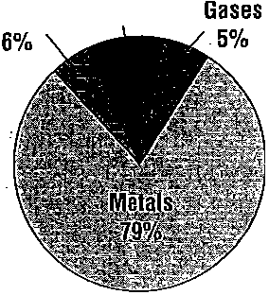
Nonmetals Noble Melalloids 10%

45
40
35
30
-
-
.c, 25
.e,. 20
15
10
5
Speed of Selected Animals Potato Production In the United States
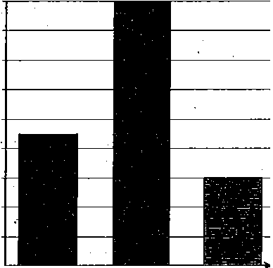25

. .
 |  |  |  |  |  |  | 1
 | . A |  | A | k | J\J |  | J
r-v |  | V

20 -
15
:iE 10
5

0

0
Racerunner

Rhinoceros Arabian
1961 1969 1977 1985 1993
Year

lizard Camel
9. 10. _

- The graph shows relationships between two variables.
- The graph shows parts of a whole.
  - 13. The graph compares variables; one variable is divided into parts, and the other variable is a number.

Measurement 17.

Name Date Class

.

Description and Measurement

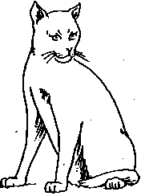
Directions: For each object below, list f our questions that can be answered by making measurements.
- _
.
.cccc Reinforcement
- - ---- --- --
1. a.
b.
c.
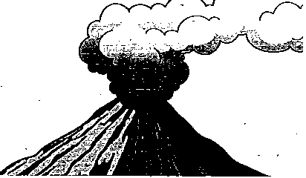
d. 2. a. b.
C,

d.

Directions: Use these measu' rements to help you estimate the measurement f or each of the objects below.

3. length of a small paper clip - --------
4. height of your classroom wastebasket _

6. length of your thumb _
CIT&2_
_ 1 mm
=o
t1 cm 1 m L!:J J

5. thickness of a staple _

0
E

C
i'l.
E
8
i
"•

Directions: Read the problem, then answer the questions that fo llow.
· The length of a piece of string is known to be exactly 9.84 cm. Two students measured the string. Student A used a ruler marked in centimeters and got a measurement of 10 cm. Student B used a ruler marked in millimeters and centimeters .and got a measurement of 9.8 cm.
- Which student's measurement is more accurate? Why?

,";
C
·a
:
0
•
- How precise is the ruler originally used to measure the string?

- What is the length of the string to the nearest centimeter?

I0. What is the length of the string to the nearest tenth of a centimeter?

Measurement 23

Name Date Class
---

---
Reinforcement
Communicating with Graphs

  - Directions: Use the graphs below to answer the f ollowing questions.
Graph A Graph C

20
'0-'
Graph·of Temperature versus Time for the Heating of Water
- -
 |  |  |  |  |  |  |  |  | c--
 |  |  | /.,.-
 | / | .,.-
V

Height of Students in Sarah's Class

18 -+-------------
16 -+-------------

·= 10
e! 0
.";

14 -+-------------
12 -+-------------

a; -10
CL
E -20
o2?
-30

0 1 2 3 4 5 6 7 8 9 10 11 12
Time in minutes
10 -+-------------
a -+--------
6 -+-------
4 +----
2

Graph B Elements Making Up Living Things
Olher elements 2.3%
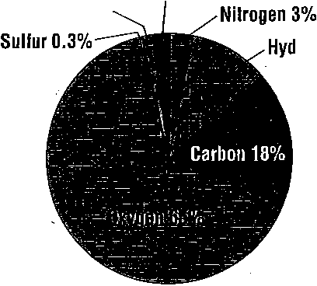
Phosphorus 1.4%
0
o ,.,ro .._.,<o .._r,'.1> ""''I,,ro"',ro"' .._r,'.b .._'\'I> ""'I,"""' ""'
Height (cm)

Hydrogen 10%

I. What type of graph is shown in A?
2. What does graph A show? _
;3, What is the independent variable in graph A? _
- On what axis is the independent variable plotted? _
- On what axis is the dependent variable plotted? _

- What type of graph is graph B? ----------- ----------
- What information, is shown in graph B? ---- ---------------
- What element makes up the largest part of living things? _

9. What type of graph is graph C?. - --- -------'----------
- What information is shown on graph C? _
- What is the most common height for students in Sarah's class? _

The Nature of Science 29

Name Date Class

--

Reinforcement
------
---
--
Standards of Measurement

Directions: Complete the table below by supplying the missing inf ormation.

'
Measurement |  | Base unit |  | Symbol
.  1. |  | meter |  | 5.
mass | 3. |  |  | 6.
2. | second |  |  | 7.
temperature | 4. |  |  | 8.

I
!

'
\
Directions: In each of the fo llowing, circle the units that would most likely be used to express each kind of . I
measurement. You may circle more than one answer fo r each term.
- volume of a solid: mL m3 cm3 L
' .
- volume of a liquid: mL mg cm3 L
- density of a material: g g/cm3 kg/m3 L
- temperature: °K K °C Kg
- mass: kg K cm3 mg
- time: kg K s mm
- length: . K km m cm
Directions: For each pair of equations, write the letter of the equation that expresses an equal value.

16. | a. 1 L = 1dm3 | b. 1L = 1 cm3
17. | a. 1mL = 1 cm3 | b. 1cm3 = 1 L
18. | a. ·0°c = -273 K | b. 0 K = '--273°C
19. | a. 1 kg = 100 g | b. 1,000 g = 1kg
20. | a. 400 cm = 4.0 m | b. 400 cm = 0.40 m
21. | a. 1dm = 10 m | b. 1 dm = 0.10 m
22. | a. 100°C = 373 K | b. 373 K = 10°C
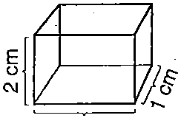
Directions: Calculate the volume of the box in the diagram.
23. ------------------------

3 cm

28 The Nature of Science

_, Name ----------------- --- Class Date _

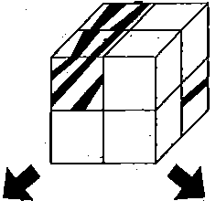
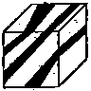
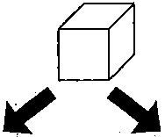
USING SCIENCE SKILLS: Interpreting a Diagram
-_,: [

:1
ii

Matter
Heterogeneous
matter
Homogeneous
matter
Solutions
§
Pure substances
Mixtures
-
Compounds Elements

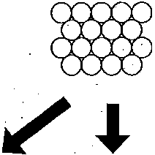
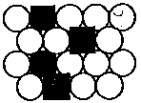
- According to the diagram, when matter is classified according to makeup, what are the

I
! i
1 1 1

1 1:
i r
i .
I
I
' I
1

two major types of matter? --------------------------

- List the two main types of homogeneous matter. -----------------

- List two kinds of pure substances. -------------- ------­

- 4. List one kind of heterogeneous matter. ----,------------------
- Where do solutions fit into this method of classification of matter? ---------
11
"1
I
, jl
I
, 1I1
I:
11
,I
,1
::
ii
11
, ,'I,
:1
'ii
'I
.I:
, I
I
: 1
I

© Prentice-Hall, Inc. 43

Name

ACTIVITY • Physical and Chemical Changes
Class .-----Date _

CHAPTER

---2)
Properties of Matter

Physical and Chemical Changes
/' t . " 4

--------------•
Type of Change

1.------------

--------------·
0 --------------•
2.------------

=
<>C' 3.------------

Q --------------• 4.------------

Phase Changes Type of Physical Change in Molecular Change Movement
w --------------• 5.------
. v!:J --------------• 6. ------
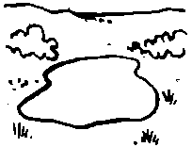 -··---·-····--• 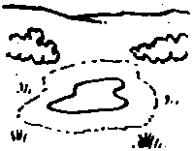 7.------
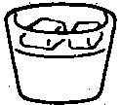 VJ:!.f!J 8.------
© Prentice-Hall, Inc. 23

Name ------------------- ·crass Date --

REVIEW and REINFORCEMENT
Compounds
Section
4-4

--------KEY CONCEPTS -------­
... Pure substances that are made of more than one element are called compounds.

  - Vocabulary Skills: Applying Definitions

On the diagram below, label correctly each of the following:

chemical formula coefficien t
chemical equation
. subscript

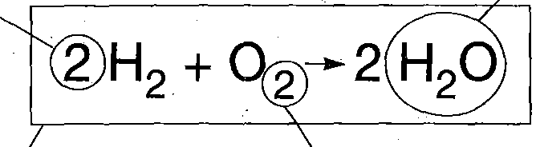

  - Elements, Compounds, and Mixtures: Reviewing the Main Ideas

Complete the chart by filling in the correct answers to each question.
 | Element | Compound | Mixture
What kind of particles make it up?
---
How can it . be broken down?
Is it the same throughout?

<

©Prentice-Hall, Inc.. 33

a Writing Formulas: Applying the Main Ideas
The drawings below show molecules of various compounds. Under each drawing, write the correct formula for the compound.

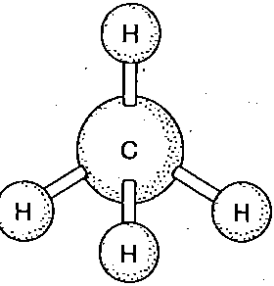
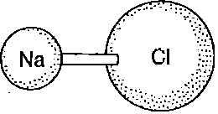
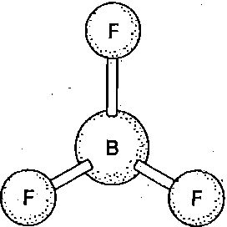

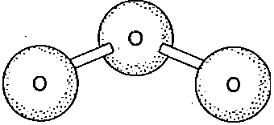
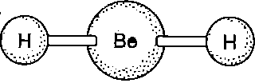

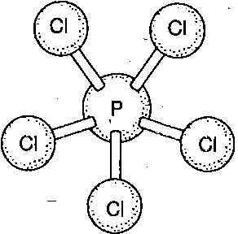
i-.i
;
I i

34

_ : .,

Blank Page

*Please do not write on this page. We may use it for an activity*

Blank Page

*Please do not write on this page. We may use it for an activity*

Blank Page

*Please do not write on this page. We may use it for an activity*

Blank Page

*Please do not write on this page. We may use it for an activity*

Blank Page

*Please do not write on this page. We may use it for an activity*

